ROYAL OAK INTERNATIONAL SCHOOL
SR. SEC. C.B.S.E. AFFILIATED
HOLIDAY HOMEWORK (SESSION 2018-19)

Subject: Math Class II Sec:____
Name: ____________ Roll no: ______

Q1. Compare the numbers and put <,>or =.
- 713 630 e) 12 112
- 120 130 f) 823 923

- 192 193 g) 679 679

- 900 800 h) 176 671

Q2. Write the short form of the following.
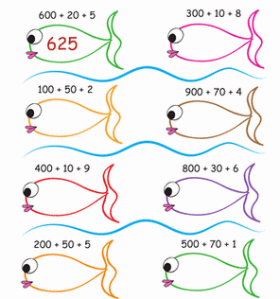
Q3. Write the next five odd numbers.
a) 31,32, ____,_____,_____,_____,______
b) 87,89, ____,_____,_____,_____,______
Q4. Colour the first,third and fifth object from the right.
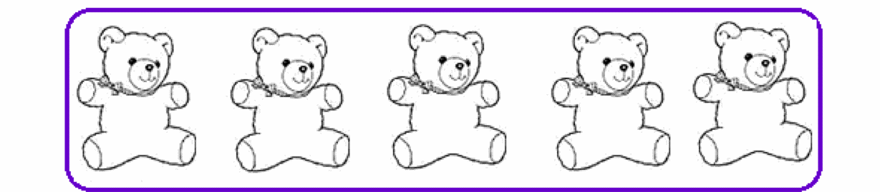

Q5. Color them according to colorcode.

a) Color the second child ‘RED’ from left.
b) Color the seventh child ‘BLUE’ from left.
Q6.A. Arrange in increasingorder.
b) 539 , 898 , 926 , 200 , 351
a) 624 ,945 , 104 ,564 , 287

B. Arrange in decreasingorder.
a) 137 , 155 , 174 , 123 , 199 ,
b)659 , 771 , 100 , 444 , 893

Q7. Write in short form.
H | T | O

a) 7 Hundred + 6 Tens + 0Ones

H | T | O

b) 8 Hundred + 0 Tens + 8Ones

c) 6 Hundred + 7 Tens + 0Ones
H | T | O

d) 500 + 80 +8
H | T | O

e) 900 + 0 + 7
H | T | O

Q8. Fill in the blanks
- In 345, the digit 4standsfor _ .
- In 980, thedigit_ is in the hundredsplace.
- In 678, the value of the digit7is .
- 10 more than945is .
- 100 less than580is

Q9. Answer the following questions.
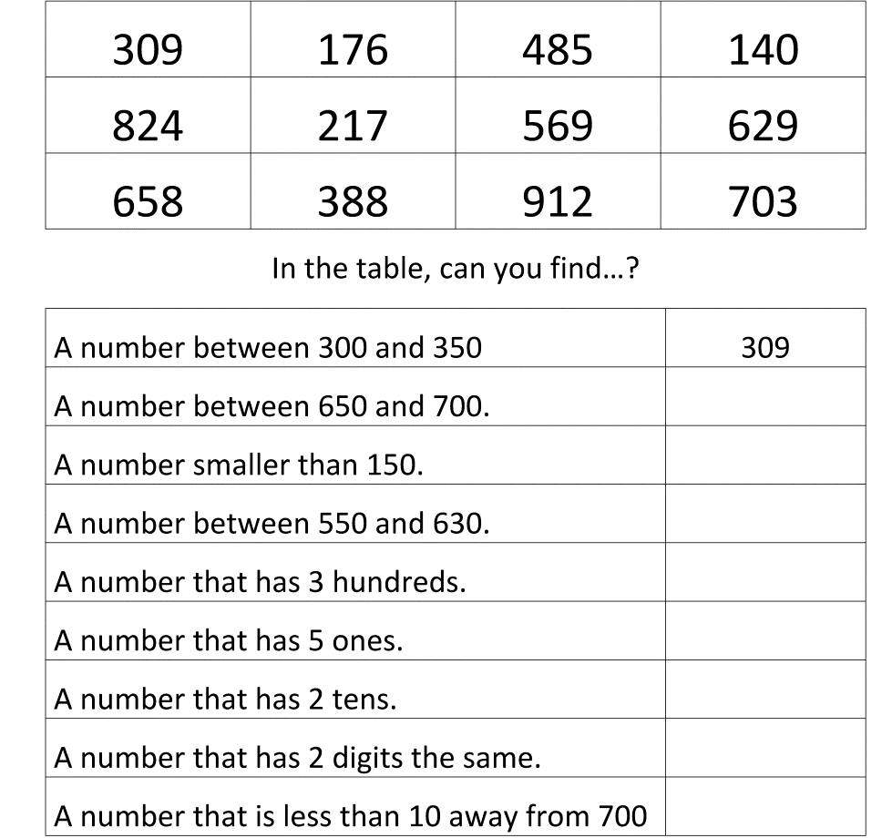

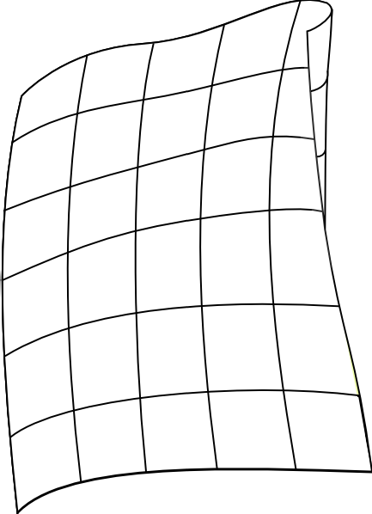Q10.Help granny to pick the colours for her new quilt. Read the place value clues and colour the quilt ac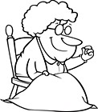cording to the colour code given.
401
5
145
621
725

941
505
791
671
925
281
345
125
301
685
190
278
351
891
288
285
881
365
561
535
381
975
781
901
815
If there is 5 in onesplace,color the square blue.
colour the square blue.
If there is 2 in hundreds place,colourthe square red.

If there is 9 in tensplace,colour the squareyellow.
If there is 1 in onesplace,colour the square green.

